React Lab Report: My First React Application

# Objectives

• Define SPA and its benefits

• Define React and identify its working

• Identify the differences between SPA and MPA

• Explain Pros & Cons of Single-Page Application

• Explain about React

• Define virtual DOM

• Explain Features of React

# Learning Outcomes

In this hands-on lab, I have learned how to:

* • Set up a React environment
* • Use create-react-app

# Prerequisites

The following are required to complete this hands-on lab:

* • Node.js
* • NPM
* • Visual Studio Code

# Estimated Time

30 minutes.

# Steps to Create and Run React Application

1. Install Node.js and NPM from: https://nodejs.org/en/download/

2. Open Command Prompt and install Create React App:  
 npx create-react-app myfirstreact

3. Navigate to the newly created folder:  
 cd myfirstreact

4. Open the folder in Visual Studio Code:  
 code .

5. Open 'App.js' file located in 'src' folder.

6. Remove all the existing content in 'App.js'.

7. Replace it with the following code:

import React from 'react';  
function App() {  
 return (  
 <div>  
 <h1>Welcome to the first session of React</h1>  
 </div>  
 );  
}  
export default App;

8. Run the React application:  
 npm start

9. Open a browser and go to: http://localhost:3000

# Screenshots (Placeholders)

Screenshot 1: Node.js and NPM Installation

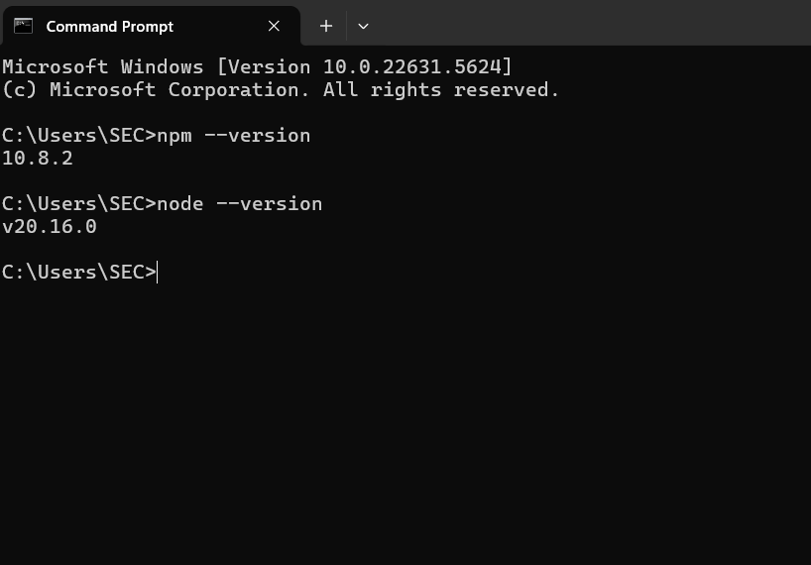

Screenshot 2: Command to create the React app

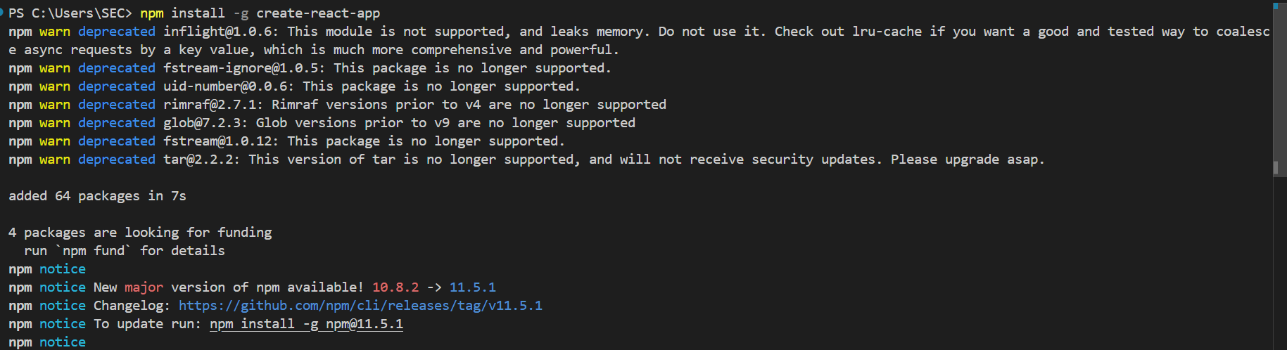Screenshot 3: Opening project in VS Code

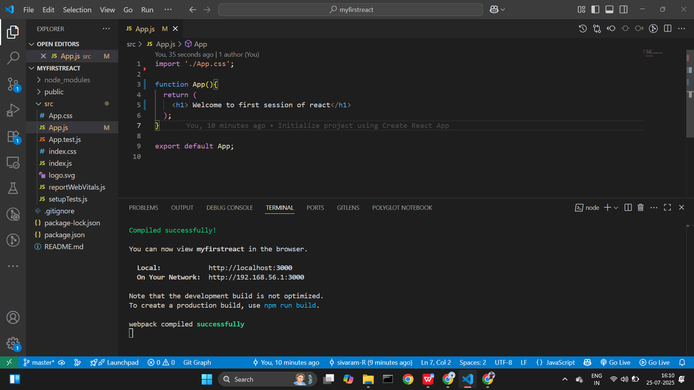Screenshot 4: Modified App.js file



Screenshot 5: Running the application



Screenshot 6: Output in browser (localhost:3000)

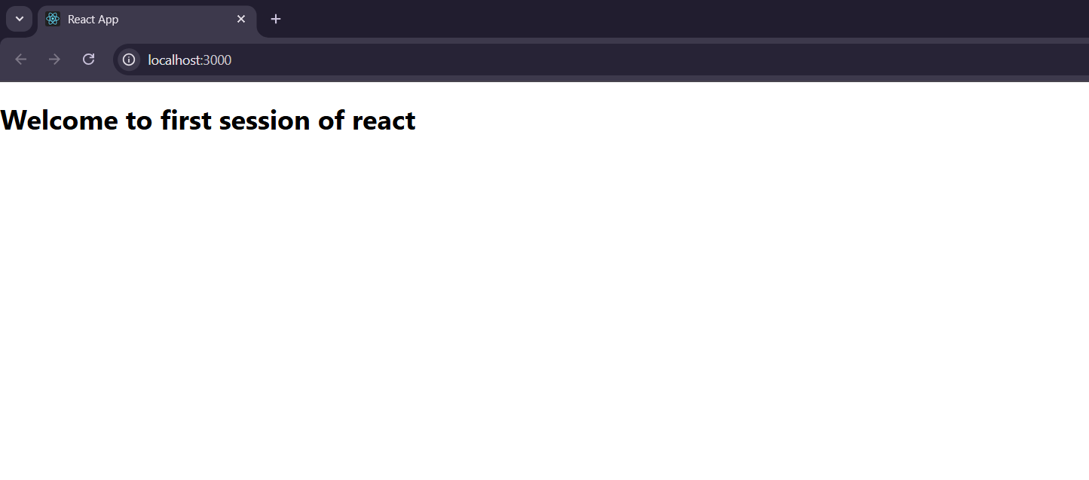

# Detailed Explanations

## SPA and its benefits

SPA (Single Page Application) is a web application that interacts with the user by dynamically rewriting the current page rather than loading entire new pages from the server. Benefits of SPA include faster user experience, reduced server load, better performance, and seamless navigation without full page reloads.

## React and its working

React is a JavaScript library for building user interfaces, especially for single-page applications. It works by maintaining a virtual DOM to efficiently update and render only the changed parts of the UI.

## Differences between SPA and MPA

SPA loads a single HTML page and updates content dynamically using JavaScript, while MPA (Multi Page Application) loads a new HTML page from the server for each route. SPA provides a smoother user experience but may have initial load overhead. MPA is better for SEO and simple applications.

## Pros & Cons of Single-Page Application

Pros:  
- Fast and responsive  
- Reduced server requests  
- Better user experience  
Cons:  
- SEO limitations  
- Browser history may be harder to manage  
- Initial loading time can be longer

## About React

React is an open-source front-end JavaScript library developed by Facebook for building reusable UI components. It allows developers to create large web applications that can update and render efficiently.

## Virtual DOM

The virtual DOM is a programming concept where a virtual representation of the UI is kept in memory and synced with the real DOM using libraries such as ReactDOM. This process is called 'reconciliation', and it helps improve performance.

## Features of React

- Component-based architecture  
- JSX (JavaScript XML) for templating  
- Virtual DOM for performance  
- Unidirectional data flow  
- Reusable components  
- Strong community support  
- Integration with other frameworks